Lab 7 – Programming Arrays, Objects

# Purpose

* Programming using Arrays
* Programming using Objects
* Upload your website to a Web server

# Due Date

* This lab must be handed in:

**Sunday Mar 12, 2017 – before midnight**

# Assessment

* This Lab is worth 2% of your total course mark.

# Estimated Time

* This Lab is estimated to take 4 hours.

This is only an estimate of the time required to complete this Lab. I would encourage you to work at your own pace and if at all possible obtain a laptop so that you can work on your assignments from anywhere

# Assigned Readings

The following chapters of ‘**Fundamentals of Web Development**’ will be useful in completing this Lab:

* Chapter 9
* Chapter 10

# Lab Supplies

To complete this lab you will require the following lab supplies:

* Textbook: **Fundamentals of Web Development**
* EasyPHP, or other WAMP server
* Eclipse, Notepad (or other text editor, or IDE)
* FileZilla (or other FTP client)

# Summary of Tasks

1. Develop the logic to display your web application
2. Upload your website to a webserver
3. View your webpage using a web browser
4. Submit Lab Link on Blackboard
5. Submit source code of all PHP files on Blackboard

# Task 1

Before getting started with the following tasks, review the ‘Common Look and Feel’ video provided on Blackboard (under: Course Content 🡪 Extra Materials). Using the knowledge gained in these materials, implement the following Design Pattern to create a ‘Common Look and Feel’ to be used on every page of your website.

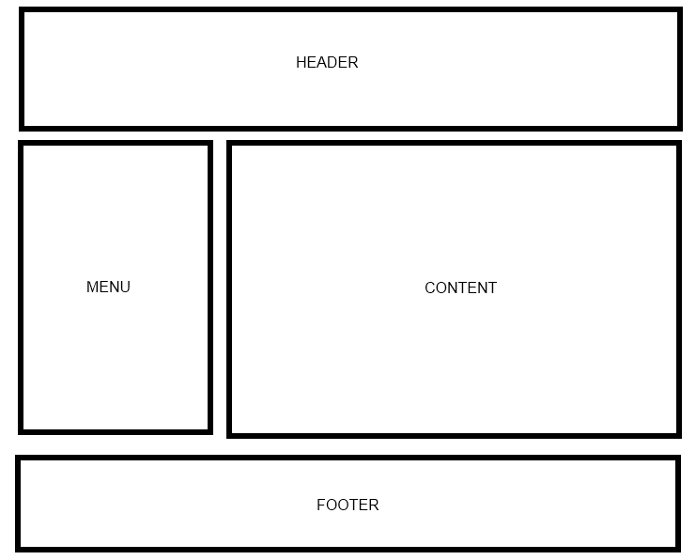

Your web site will include the following PHP scripts:

* Header.php
* Footer.php
* Menu.php
* Array1.php
* Array2.php
* Object.php

**Header.php**

Header.php must contain a script to display a Common Header that will appear on every page. The header must contain a banner (images, css, etc).

**Footer.php**

Footer.php must contain a script to display a Common Footer that will appear on every page. The footer must contain Student Number, First Name, Last Name, and Email Address

**Menu.php**

Menu.php must contain a script to display a Common Menu to be shown on every page. The menu must contain links to Array1.php, Array2.php and Object.php

**Array1.php**

Create a PHP script that will perform the following tasks.

1. Create a multidimensional array called **‘$March**’.
2. Implement the array as follows:

|  |  |  |  |  |
| --- | --- | --- | --- | --- |
| 1st | 2nd | 3rd | 4th | 5th |
| 3 | 10 | 17 | 24 | 31 |

Friday

|  |  |  |  |
| --- | --- | --- | --- |
| 1st | 2nd | 3rd | 4th |
| 4 | 11 | 18 | 25 |

Saturday

|  |  |  |  |
| --- | --- | --- | --- |
| 1st | 2nd | 3rd | 4th |
| 5 | 12 | 19 | 26 |

Sunday

**$March**

|  |  |  |  |
| --- | --- | --- | --- |
| 1st | 2nd | 3rd | 4th |
| 6 | 13 | 20 | 27 |

Monday

|  |  |  |  |
| --- | --- | --- | --- |
| 1st | 2nd | 3rd | 4th |
| 7 | 14 | 21 | 28 |

Tuesday

|  |  |  |  |
| --- | --- | --- | --- |
| 1st | 2nd | 3rd | 4th |
| 8 | 15 | 22 | 29 |

Wednesday

|  |  |  |  |
| --- | --- | --- | --- |
| 1st | 2nd | 3rd | 4th |
| 9 | 16 | 23 | 30 |

Thursday

1. Place a header (h2) on the page with the following word ‘Output-1’. Use appropriate built-in function to display the contents of the array as ***key->value*** pair.

Sample output is as follows:

*Array ( [Monday] => Array ( [1st] => 3 [2nd] => 10 [3rd] => 17 [4th] => 24 [5th] => 31)*

*[Tuesday] => Array ( [1st] => 4 [2nd] => 11 [3rd] => 18 [4th] => 25)*

*………*

*………… )*

1. Place a header (h2) on the page with the following word ‘Output-2’. Apply appropriate **loop** to display the following text where you must use the ***values****(e.g., 3,10,17, 24, ….)* and ***keys****(e.g., 1st, 2nd, …., Friday, Saturday, ….)* of the **$March** array:

*3 is the 1st Friday in March.*

*10 is the 2nd Friday in March.*

*17 is the 3rd Friday in March.*

*24 is the 4th Friday in March.*

*31 is the 5th Friday in March.*

*4 is the 1st Saturday in March.*

*11 is the 2nd Saturday in March.*

*18 is the 3rd Saturday in March.*

*25 is the 4th Saturday in March.*

*.*

*…………………………………….*

*……………………………..*

*30 is the 4th Thursday in March.*

1. Place a header (h2) on the page with the following word ‘Output-3’. Use appropriate built-in **array** function to display the contents of the array in reverse order.
2. Place a header (h2) on the page with the following word ‘Output-4’. Use appropriate built-in **sort** function to sort the array in reverse order and display the contents of the array.
3. Place a header (h2) on the page with the following word ‘Output-5’. Add ‘***32***’ as the ‘**5th**’ element of ‘**Saturday**’ in ***$March*** array and display the contents of the array.
4. Include common Header, Menu and Footer to the page.

**Array2.php**

Create a PHP script that will generate the outcome shown below. Your code must be able to convert from Canadian Dollar to NewZealand Dollar and vice versa; Canadian Dollar to US Dollar and vice versa;  US Dollar to NewZealand Dollar and vice versa. You must implement it using HTML form elements as well as associative array of PHP.

|  |
| --- |
| C:\Users\chowdhr\Desktop\CAD.jpg |

The form fields are as follows:

Conversion amount:          srcamt

Base currency:      basecurr

Destination currency: destcurr

You have two arrays already declared with the following information:

$currencies = array(    "CAD" => "Canadian Dollar",

   "NZD" => "New Zealand Dollar",

   "USD" => "US Dollar");

$rates = array(  "CAD" => 0.97645,

   "NZD" => 1.20642,

   "USD" => 1.0         );

**Hints for solving Array2.php:**

Formula for Currency Coversion:

$converted_output = ($amount_input/$rates[$basecurr]) * $rates[$destcurr]

For example:

* CAD to NZD conversion:

If you want to convert from 100 CAD to eqivalent NZD, the formula works as follows:

$converted_output = ($amount_input/$rates[$basecurr]) * $rates[$destcurr]

= ($amount_input/$rates[CAD]) * $rates[NZD]

= (100/0.97645) * 1.20642

= 123.55

Expected Output = 100.00 Canadian Dollar converts to 123.55 New Zealand Dollar

* NZD to CAD conversion:

If you want to convert from 123.55 NZD to eqivalent CAD, the formula works as follows:

$converted_output = ($amount_input/$rates[$basecurr]) * $rates[$destcurr]

= ($amount_input/$rates[NZD]) * $rates[CAD]

= (123.55/1.20642) * 0.97645

= 100.00

Expected Output = 123.55 New Zealand Dollar converts to 100.00 Canadian Dollar

**Object.php**

Create a PHP script that will perform the following tasks.

1. Define a class ***Vehicle*** which has protected properties: ***make, model, year, price.*** Create a ***constructor*** method that takes in ***make, model, year,*** and ***price.*** Implement a public method ***displayObject()*** to display the properties of each object instance.
2. Define a derived class ***LandVehicle*** that inherits from the ***Vehicle*** class and contains a private property: ***maxSpeed***. You may need to override the ***constructor*** and ***displayObject()*** method for this derived class.
3. Define another derived class ***WaterVehicle*** that also inherits from the ***Vehicle*** class and contains private property: ***boatCapacity***. You may need to override the ***constructor*** and ***displayObject()*** method for this derived class.
4. Instantiate (Create) at least three objects of ***LandVehicle*** and display the properties of each object instance. Sample output is as follows:

|  |  |  |  |  |  |  |  |  |  |  |
| --- | --- | --- | --- | --- | --- | --- | --- | --- | --- | --- |
| |  |  |  |  |  | | --- | --- | --- | --- | --- | | Make:Toyota, | Model:Camry, | Year:1992, | Price:2000, | Speed Limit:180 |  |  |  |  |  |  | | --- | --- | --- | --- | --- | | Make:Honda, | Model:Accord, | Year:2002, | Price:6000, | Speed Limit:200 | |

1. Instantiate (Create) at least three objects of ***WaterVehicle*** and display the properties of each object instance. Sample output is as follows:

|  |  |  |  |  |  |  |  |  |  |  |
| --- | --- | --- | --- | --- | --- | --- | --- | --- | --- | --- |
| |  |  |  |  |  | | --- | --- | --- | --- | --- | | Make:Mitsubishi, | Model:Turbo, | Year:1999, | Price:20000, | Boat Capacity:18 |  |  |  |  |  |  | | --- | --- | --- | --- | --- | | Make:Hyundai, | Model:XT, | Year:2012, | Price:26000, | Boat Capacity:8 | |

1. Include common Header, Menu and Footer to the page.

# Task 2

Upload your website to a Web server. Use an FTP client to connect to your Web server.

Once you connect to the webserver using an FTP client, create a directory called ‘/CST8238/Lab7’. Once your course directory has been created navigate to that new directory. Add your index.php file to this location. (Using FileZilla simply drag the index.php file into your folder). The index.php file will refer to all of your php files.

# Task 3

View your website using a web browser. Open a web browser and navigate to the following web address:

**http://web-server_domain_name/CST8238/Lab7/<filename>**

For example, the web address to my page is:   
http://profrejaul.com/CST8238/Lab7/index.php

Where ‘profrejaul.com’ is the domain name of the Web server, ‘ /CST8238/Lab7’ is the name of the directory I created in the Web server using FTP client and ‘index.php’ is the web page I created for this lab.

# Task 4

Once you have confirmed that your webpage is available online, you are ready to hand in your lab.  
  
To hand in your lab go to Blackboard and navigate to Course Content 🡪 Labs and click on ‘Lab 7 – Programming Arrays, Objects’ link.

Under “Assignment Materials”, in the Submission text box write out the following Information:

* Student Number
* First Name
* Last Name
* The URL, or hyperlink, prepared in Task 3

Under “Assignment Submission”, submit (attach) following PHP files:

* Header.php
* Footer.php
* Menu.php
* Array1.php
* Array2.php
* Object.php

Finally, once the Submission and Comments section are complete, click the ‘Submit’ button to send the lab to your professor.

**IMPORTANT NOTE**:

If the URL, or hyperlink, does not direct the professor to the lab you will receive a ZERO for the lab assignment.

**IMPORTANT NOTE:**

You may only submit a Lab ONE TIME. Be sure the lab is complete before clicking on the ‘Submit’ button.